**Object Oriented Programming**

Object is an entity which has well define structure and behavior.

**4 Characteristics of the Object:**

**1] State:**

The current value of an attribute is called as state.

**2] Behavior:**

How it acts and reacts on the state change

Behavior is depending on the state.

Behavior is the method.

**3] Identity:**

Each and every attribute which acts unique.

Different object has different identity.

**4] Responsibility:**

What kind of role it plays in the is the Responsibility

* Object can be tangible or can be conceptual.

**To support OOPS there are 4 major pillar and 3 minor pillar.**

* **Major:**

1] Abstraction

2] Encapsulation

3] Inheritance

4] Polymorphism

* **Minor:**

1] Strongly Type casting

2] Concurrency

3] Persistence

**Ex:**

Lets take the **Employee** as an state.

Attributes are like

* empid
* empname
* empsalary
* empDOB
* empjoiningdate
* empdept
* empbatch
* empaddress
* empcontact
* empemail

**Types of Attributes:**

1] static: it is like fixed attributes

2] Dynamic: changing attributes.

**Abstraction:**

PIKING UP THE IMP REQUIRE ATTRIBUTES AND PUTTING THEM INTO THE CLASS AND MAKING THEM PRIVATE

**Encapsulation:**

DATA HIDING AND MAKING THEM THE PROTECTED.

Encapsulation is basically the method, function and the process which are publicly available.

**Inheritance:**

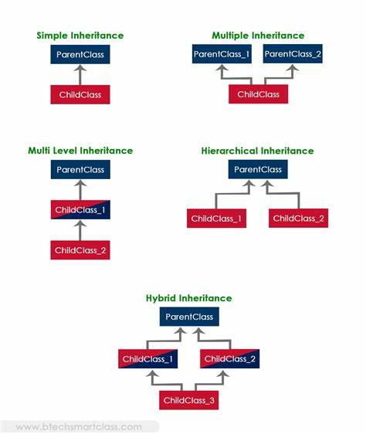

**Polymorphism:**

Command is same implementation is different.

**Typecasting:**  is to change the existing data type to the variable.

**Concurrency** is like the multithreaded

**Persistence** is the process or can say as modes.

**Three types of languages**

*Object base language*: Any language support First 2 major pillars.

*OOPS language*: Any language which supports 4 major pillars languages.

*Strongly OOPS*: Any language which support all the major and the minor pillars language.